 



Database Programming with SQL

* 1. : Intro to Constraints; NOT NULL and UNIQUE Constraints Practice Activities

# Objectives

* + - Define the term "constraint" as it relates to data integrity
    - State when it is possible to define a constraint at the column level, and when it is possible at the table level
    - State why it is important to give meaningful names to constraints
    - State which data integrity rules are enforced by NOT NULL and UNIQUE constraints
    - Write a CREATE TABLE statement which includes NOT NULL and UNIQUE constraints at the table and column levels
    - Explain how constraints are created at the time of table creation

# Vocabulary

Identify the vocabulary word for each definition below.

|  |  |
| --- | --- |
| **UNIQUE Constraint** | Every value in a column or set of columns (a composite key) must be unique |
| **NOT NULL Constraint** | For every row entered into the table, there must be a value for that column |
| **PRIMARY KEY** | Constraint ensures that the column contains no null values and uniquely identifies each row of the table |
| **CHECK Constraint** | Specifies a condition for a column that must be true for each row of data |
| **REFERENCES** | Identifies that table and column in the parent table |
| **UNIQUE Constraint** | An integrity constraint that requires every value in a column or set of columns be unique |
| **FOREIGN KEY** | Designates a column (child table) that establishes a relationship between a primary key in the same table and a different table (parent table) |
| **Table Level Constraint** | References one or more columns and is defined separately from the definitions of the columns in the table |
| **Constraint** | Database rule. |
| **Column Level Constraint** | Database rule that references a single column |

# Try It / Solve It

Global Fast Foods has been very successful this past year and has opened several new stores. They need to add a table to their database to store information about each of their store’s locations. The owners want to make sure that all entries have an identification number, date opened, address, and city and that no other entry in the table can have the same email address. Based on this information, answer the following questions about the global_locations table. Use the table for your answers.

|  |  |  |  |  |  |  |
| --- | --- | --- | --- | --- | --- | --- |
| **Global Fast Foods global_locations Table** | | | | | | |
| NAME | TYPE | LENGTH | PRECISION | SCALE | NULLABLE | DEFAULT |
| Id | PK |  |  |  | NO |  |
| name |  |  |  |  |  |  |
| date_opened |  |  |  |  | NO |  |
| address |  |  |  |  | NO |  |
| city |  |  |  |  | NO |  |
| zip/postal code |  |  |  |  |  |  |
| phone |  |  |  |  |  |  |
| email | UK |  |  |  |  |  |
| manager_id |  |  |  |  |  |  |
| Emergency contact |  |  |  |  |  |  |

PK – primary key

UK – unique key

FK – foreign key

1. What is a “constraint” as it relates to data integrity?

**База данных может быть такой же надежной, как и данные в ней, а правила базы данных реализуются как ограничения для поддержания целостности данных. Например, эти ограничения могут запрещать удаление таблицы или какой-либо строки при выполнении вставки, обновления или удаления. Тип ограничений:**

**PRIMARY KEY Constraint**

•         **UNIQUE Constraint**

•         **FOREIGN KEY Constraint**

•         **CHECK Constraint with condition applied on the column/columns (they work at row level)**

•         **NOT NULL Constraint (implemented at row level using special CHECK Constraint having condition IS NOT NULL for single column)**

1. What are the limitations of constraints that may be applied at the column level and at the table level?

**Ограничения, относящиеся к более чем одному столбцу, определяются на уровне таблицы.**

**Ограничение NOT NULL должно быть определено на уровне столбца в соответствии со стандартом ANSI/ISO SQL.**

**Если в операторе CREATE TABLE используется слово CONSTRAINT, я должен указать имя ограничения. Кроме того, именно поэтому ограничение уровня таблицы должно быть названо пользователем.**

1. Why is it important to give meaningful names to constraints?

**Если ограничение нарушается при выполнении оператора SQL, легко определить причину с помощью ограничений, названных пользователем.**

•         **Легко изменить имя/ограничение удаления.**

•         **Обработка производственных проблем может быть быстрее с пользовательскими ограничениями**

1. Based on the information provided by the owners, choose a datatype for each column. Indicate the length, precision, and scale for each NUMBER datatype.

|  |  |  |  |  |  |  |
| --- | --- | --- | --- | --- | --- | --- |
| **Global Fast Foods global_locations Table** | | | | | | |
| NAME | TYPE | DataType | LENGTH | PRECISION | SCALE | NULLABLE |
| id | pk | **NUMBER** | **6** | **0** |  | No |
| name |  | **VARCHAR2** | **50** |  |  |  |
| date_opened |  | **DATE** |  |  |  | No |
| address |  | **VARCHAR2** | **50** |  |  | No |
| city |  | **VARCHAR2** | **30** |  |  | No |
| zip_postal_code |  | **VARCHAR2** | **12** |  |  |  |
| phone |  | **VARCHAR2** | **20** |  |  |  |
| email | uk | **VARCHAR2** | **75** |  |  |  |
| manager_id |  | **NUMBER** | **6** | **0** |  |  |
| emergency_contact |  | **VARCHAR2** | **20** |  |  |  |

1. Use “nullable” to indicate those columns that can have null values.

|  |  |  |  |  |  |  |
| --- | --- | --- | --- | --- | --- | --- |
| **Global Fast Foods global_locations Table** | | | | | | |
| NAME | TYPE | DataType | LENGTH | PRECISION | SCALE | NULLABLE |
| id | pk | NUMBER | 6 | 0 |  | No |
| name |  | VARCHAR2 | 50 |  |  | Yes |
| date_opened |  | DATE |  |  |  | No |
| address |  | VARCHAR2 | 50 |  |  | No |
| city |  | VARCHAR2 | 30 |  |  | No |
| zip_postal_code |  | VARCHAR2 | 12 |  |  | Yes |
| phone |  | VARCHAR2 | 20 |  |  | Yes |
| email | uk | VARCHAR2 | 75 |  |  | Yes |
| manager_id |  | NUMBER | 6 | 0 |  | Yes |
| emergency_contact |  | VARCHAR2 | 20 |  |  | Yes |

1. Write the CREATE TABLE statement for the Global Fast Foods locations table to define the constraints at the column level.

CREATE TABLE f_global_locations

( id NUMBER(6,0) CONSTRAINT f_gln_id_pk PRIMARY KEY ,

name VARCHAR2(50),

date_opened DATE CONSTRAINT f_gln_dt_opened_nn NOT NULL ENABLE,

address VARCHAR2(50) CONSTRAINT f_gln_add_nn NOT NULL ENABLE,

city VARCHAR2(30) CONSTRAINT f_gln_city_nn NOT NULL ENABLE,

zip_postal_code VARCHAR2(12),

phone VARCHAR2(20),

email VARCHAR2(75) CONSTRAINT f_gln_email_uk UNIQUE,

manager_id NUMBER(6,0),

emergency_contact VARCHAR2(20)

);

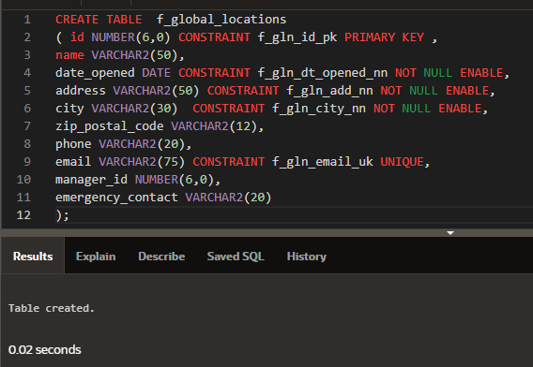

1. Execute the CREATE TABLE statement in Oracle Application Express.
2. Execute a DESCRIBE command to view the Table Summary information.

DESCRIBE f_global_locations;

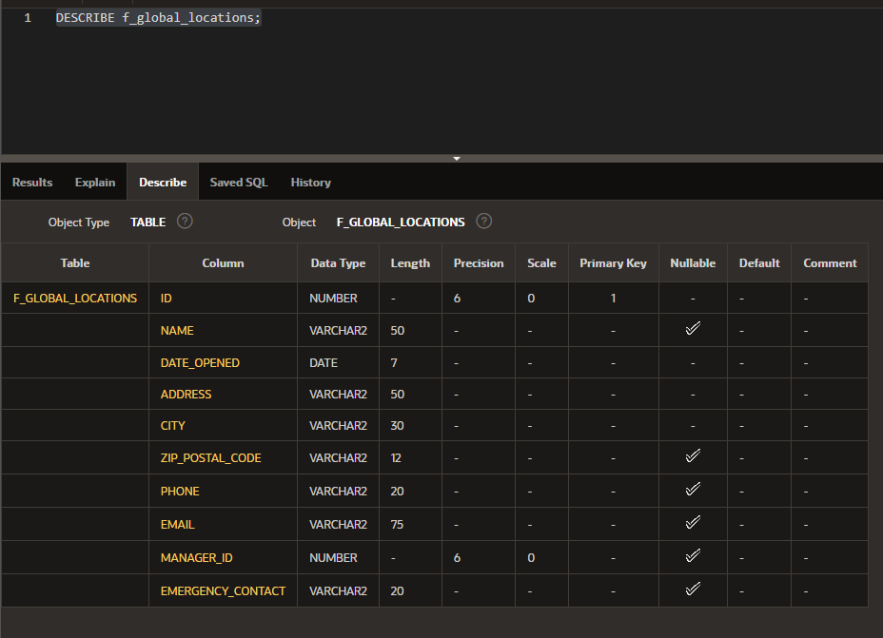

1. Rewrite the CREATE TABLE statement for the Global Fast Foods locations table to define the UNIQUE constraints at the table level. Do not execute this statement.

CREATE TABLE f_global_locations

( id NUMBER(6,0) CONSTRAINT f_gln_id_pk PRIMARY KEY ,

name VARCHAR2(50),

date_opened DATE CONSTRAINT f_gln_dt_opened_nn NOT NULL ENABLE,

address VARCHAR2(50) CONSTRAINT f_gln_add_nn NOT NULL ENABLE,

city VARCHAR2(30) CONSTRAINT f_gln_city_nn NOT NULL ENABLE,

zip_postal_code VARCHAR2(12),

phone VARCHAR2(20),

email VARCHAR2(75) ,

manager_id NUMBER(6,0),

emergency_contact VARCHAR2(20),

CONSTRAINT f_gln_email_uk UNIQUE(email)

);

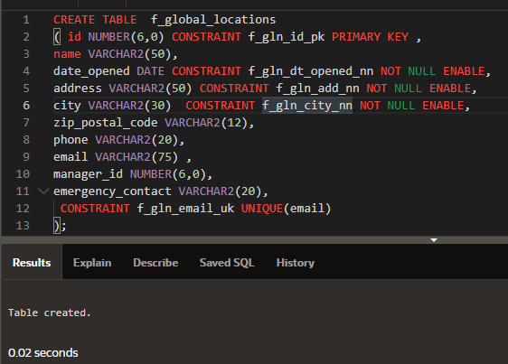

Copyright © 2020, Oracle and/or its affiliates. All rights reserved. Oracle and Java are registered trademarks of Oracle and/or its affiliates. Other names may be trademarks of their respective owners.